IKCEST总平台注册及选课流程

Applicable to PC：

Step 1 Enter the URL:
http://new.ikcest.org/my/register.htm?returnUrl=http://new.ikcest.org/my/training_userlist.htm&type=srst

Step 2 Fill in the information below and click “register ”

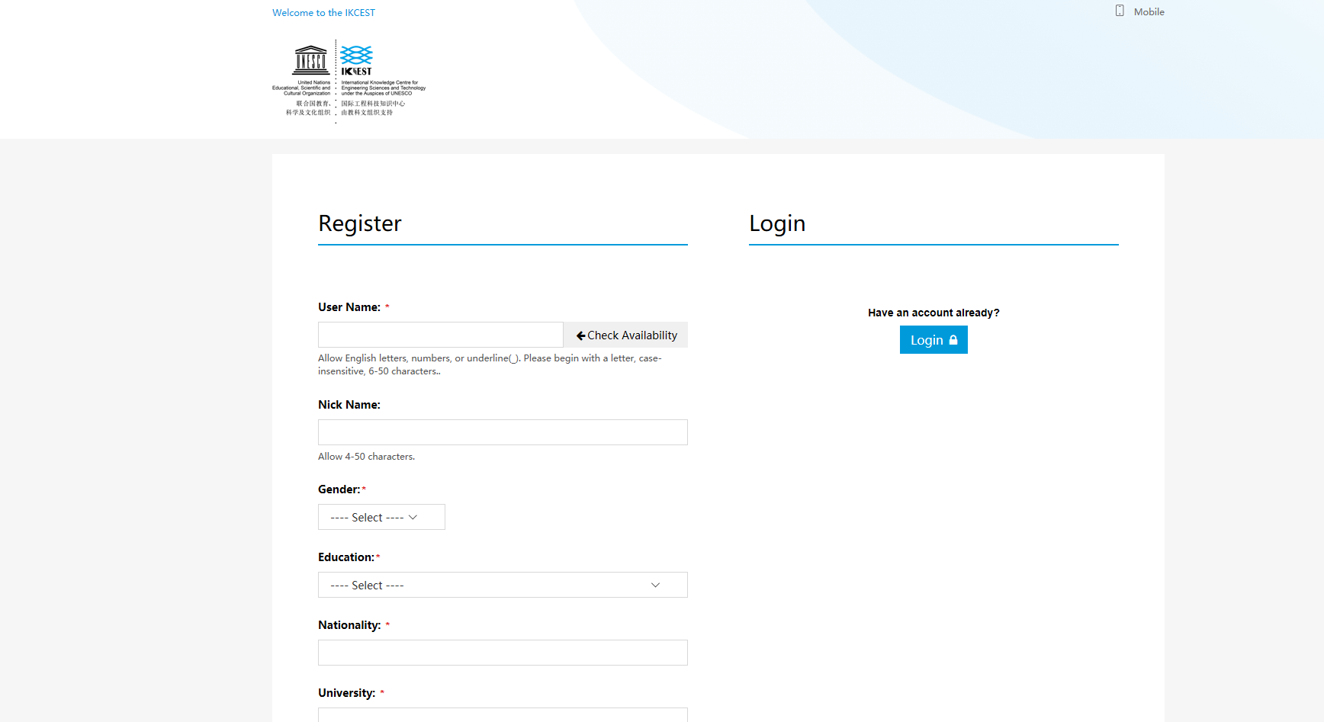
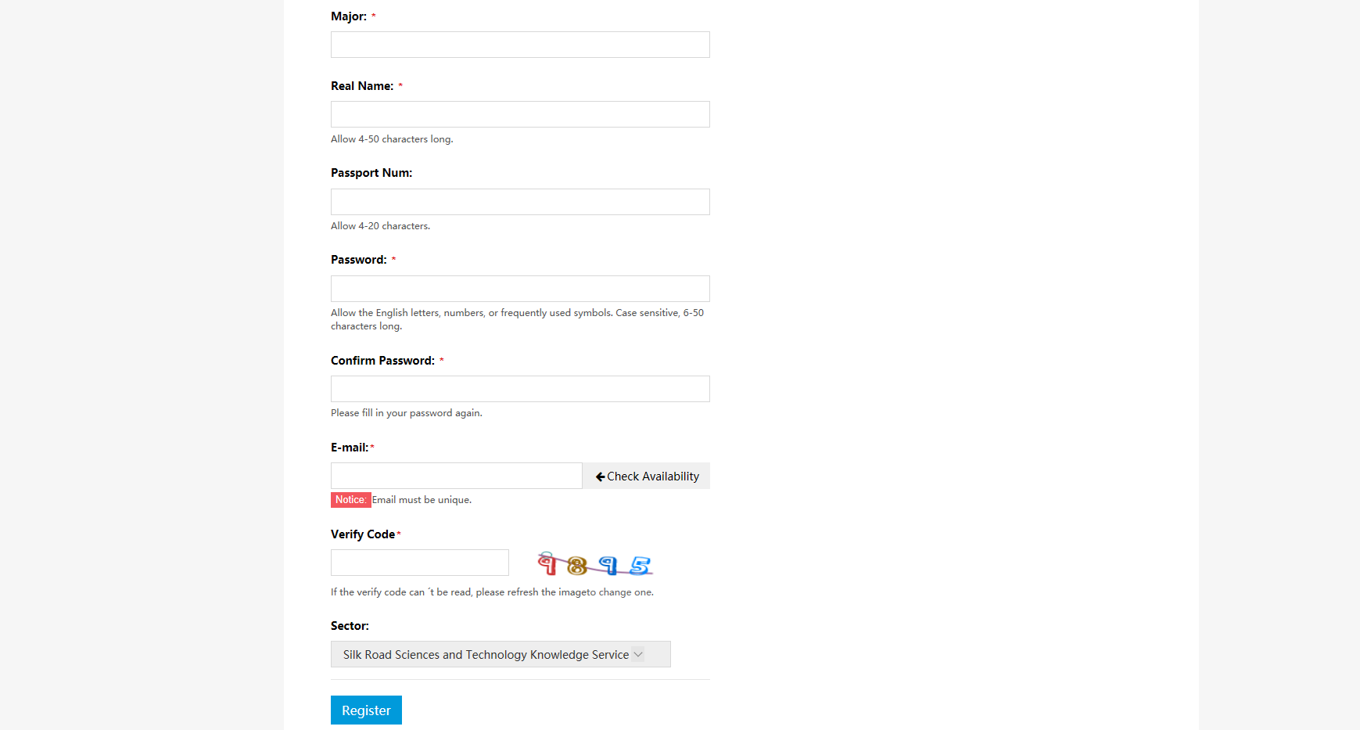
Step 3 Click “+Register”

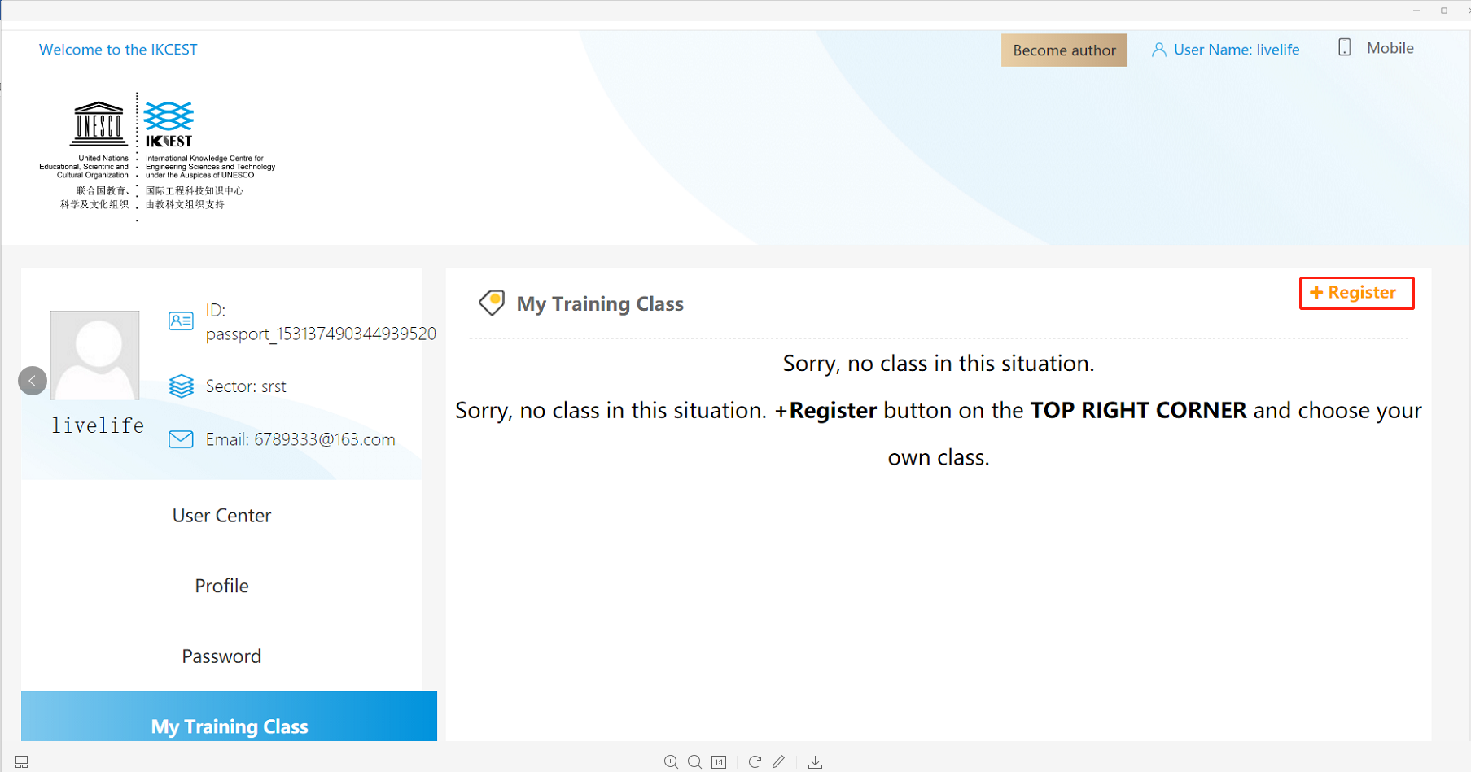

Step 4 Select Programme and Input the Verify Code

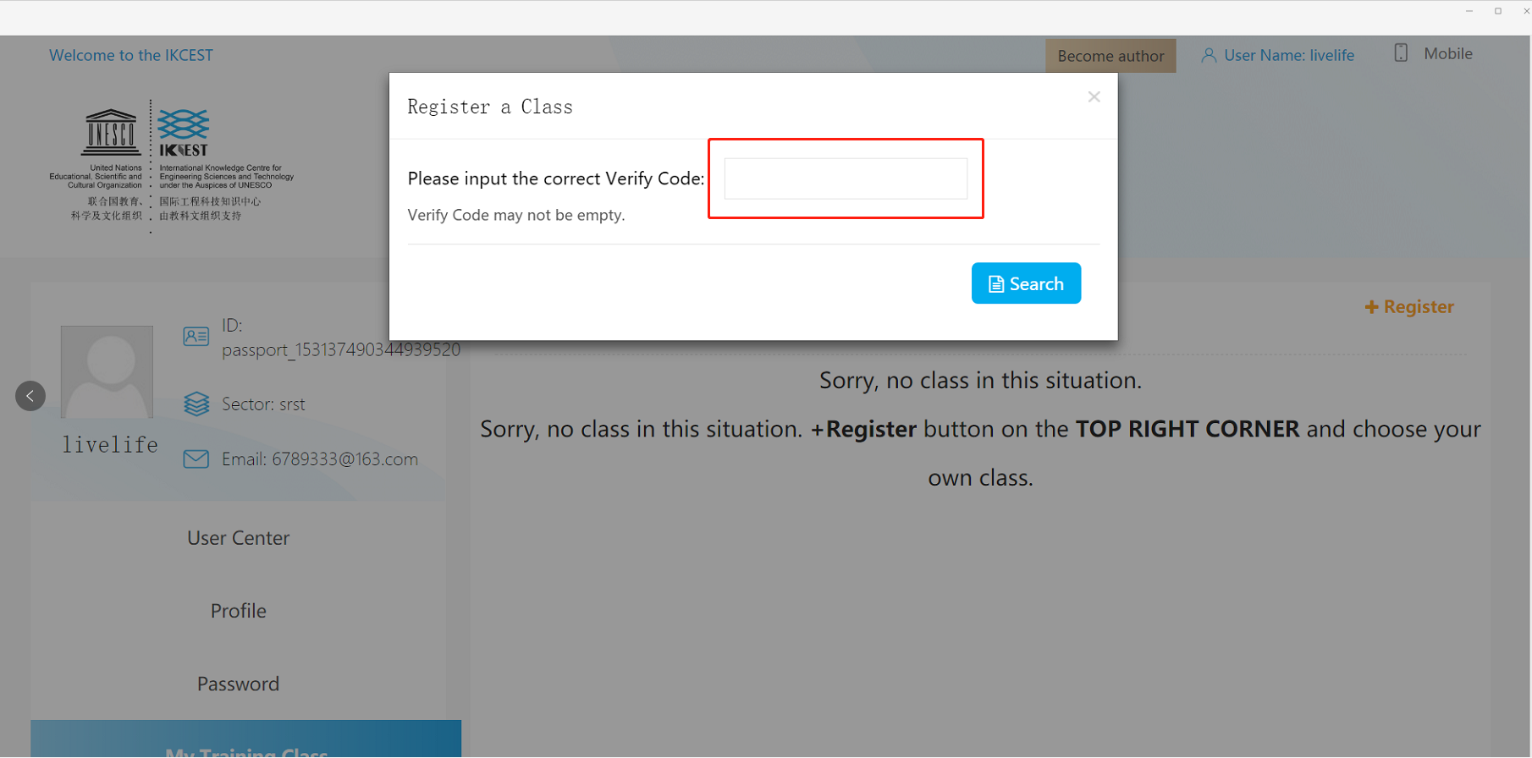

Step 5 Confirm Registration

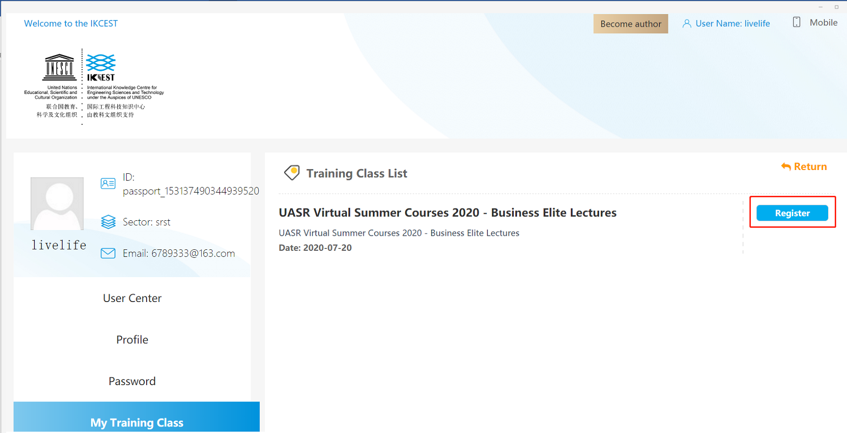

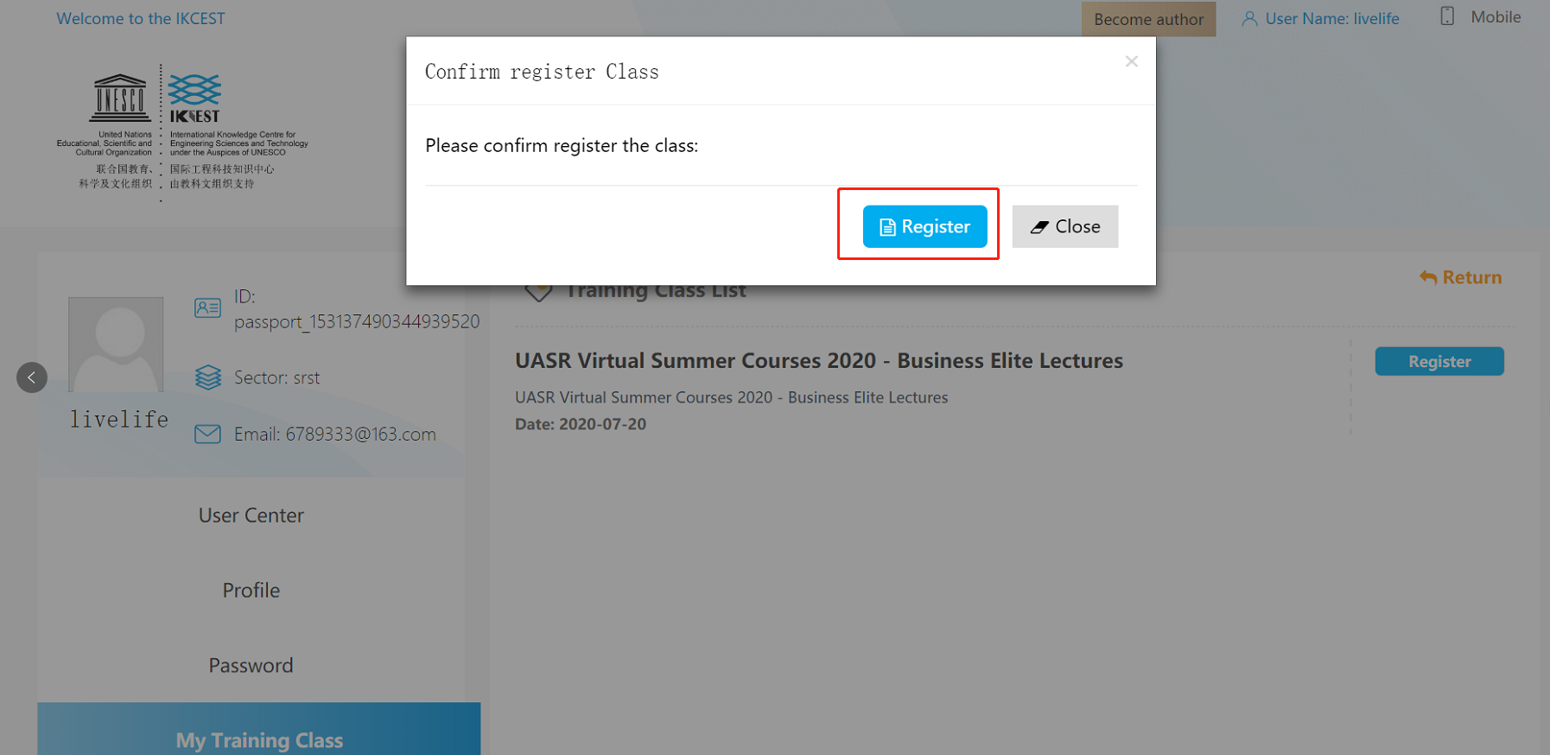

Step 6 Register Successfully !

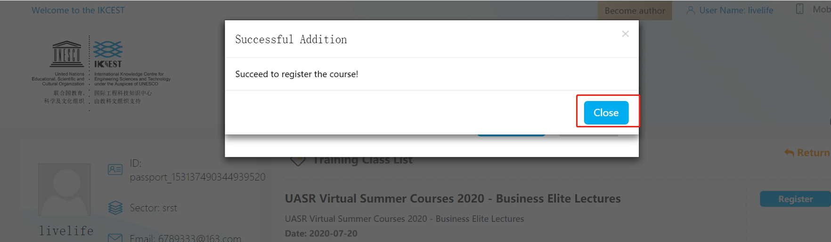

Step 7 (After programme) Click “Start Survey” and “Start Exam” to finish it.

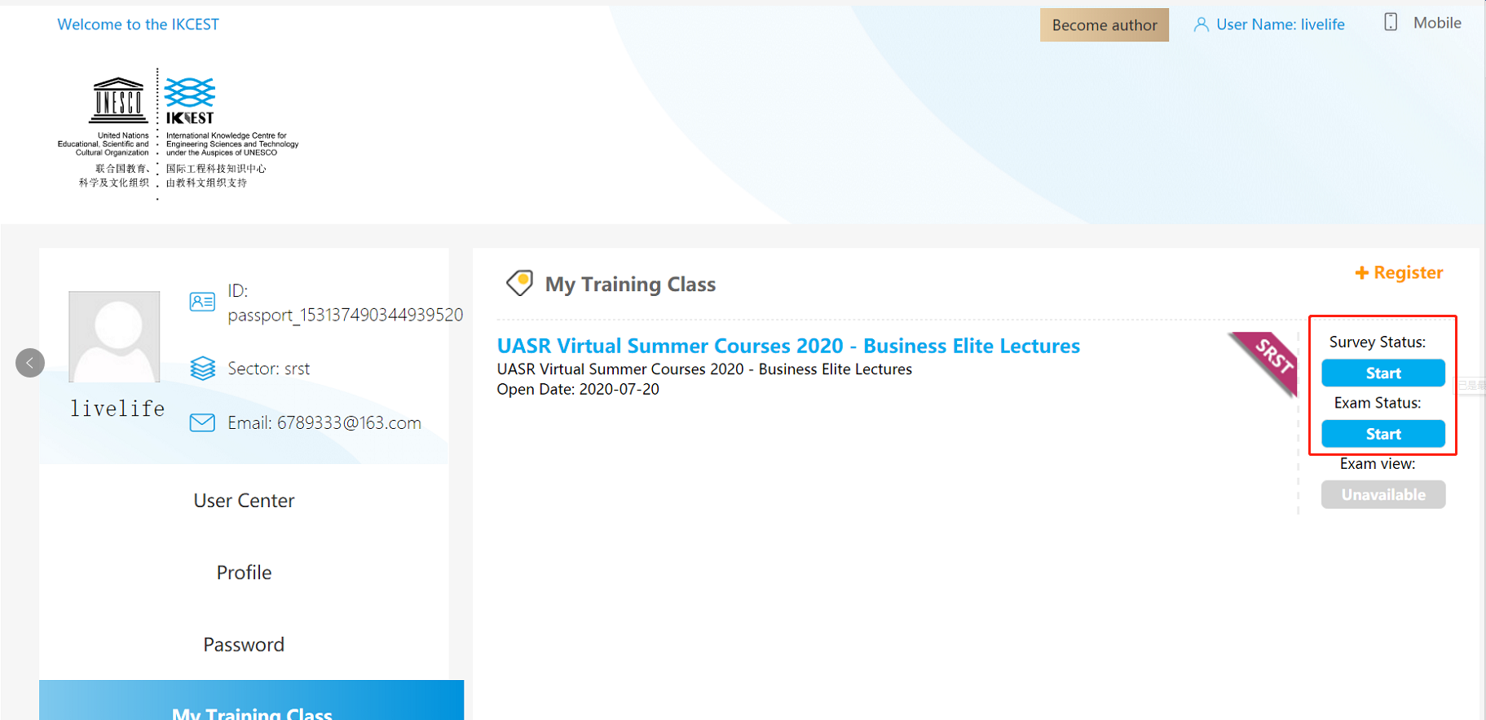

Applicable to smartphone：

Step 1 Scan the QR code:
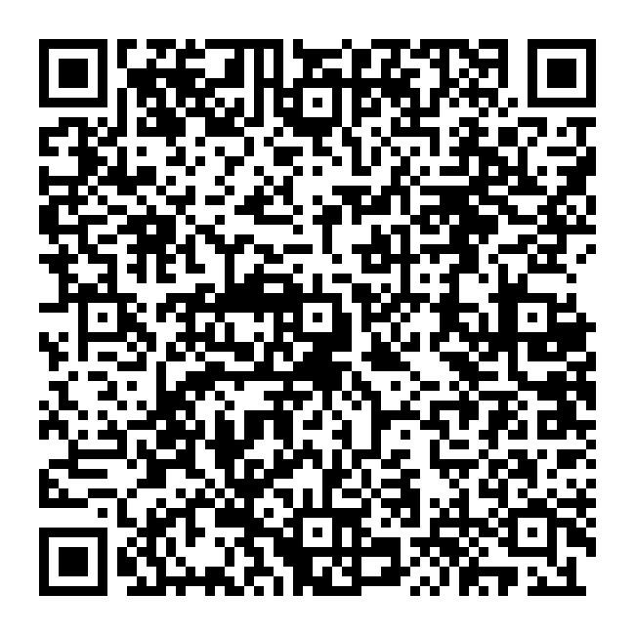
Step 2 Fill in the information below and click “register ”
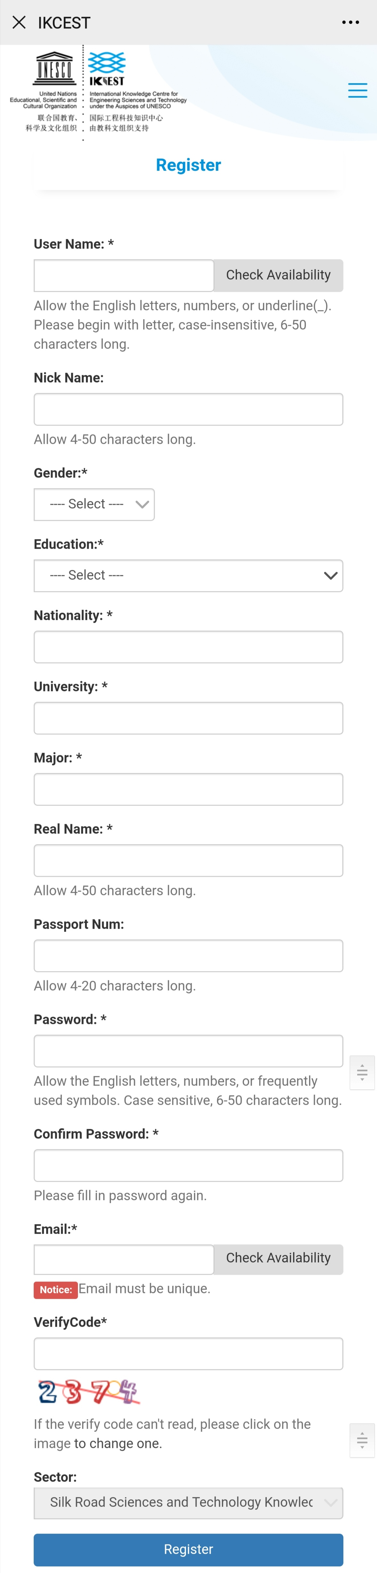
Step 3 Click “+Register”

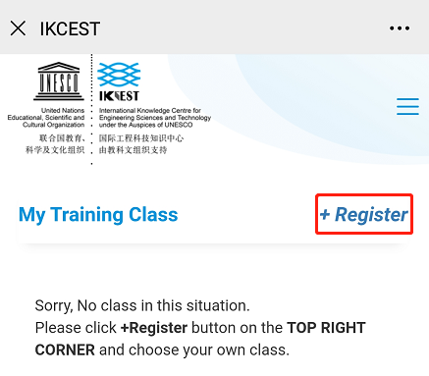
Step 4 Select Programme and Input the Verify Code

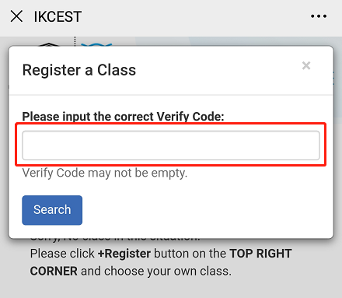
Step 5 Click “Register” and Confirm Registration
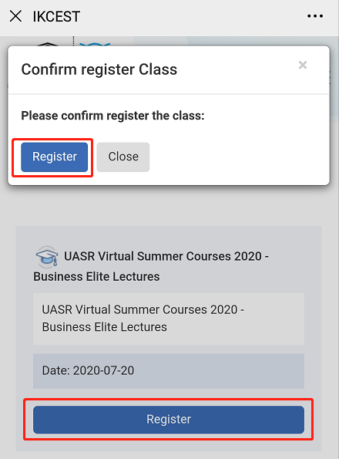
Step 6 Register Successfully !
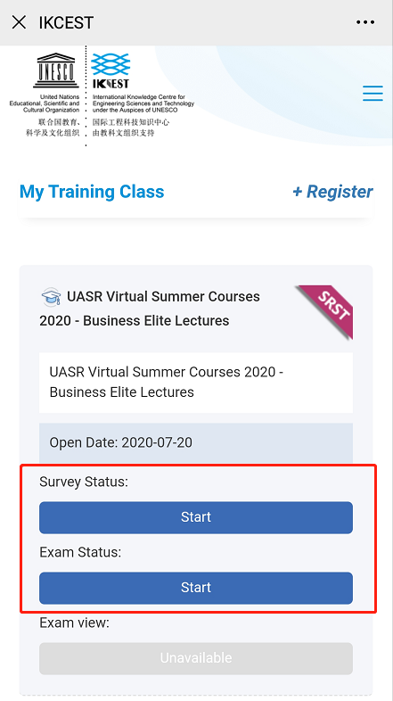

Step 7 (After programme) Click “Start Survey” and “Start Exam” to finish it.

THANK YOU

Website: http://silkroadst.ikcest.org
Contacts: Mr. Du
Tel: 029-82667916
Email: duhaipeng@xjtu.edu.cn

